**Task 4. Enable Multi-Factor Authentication (MFA) for "S3-User":**

Steps to enable Multi-Factor Authentication (MFA) for “S3-User”

* In the IAM console, click on "Users" on the left side menu and next in the User Info menu click on the S3-User.

In User info go in the security credentials.

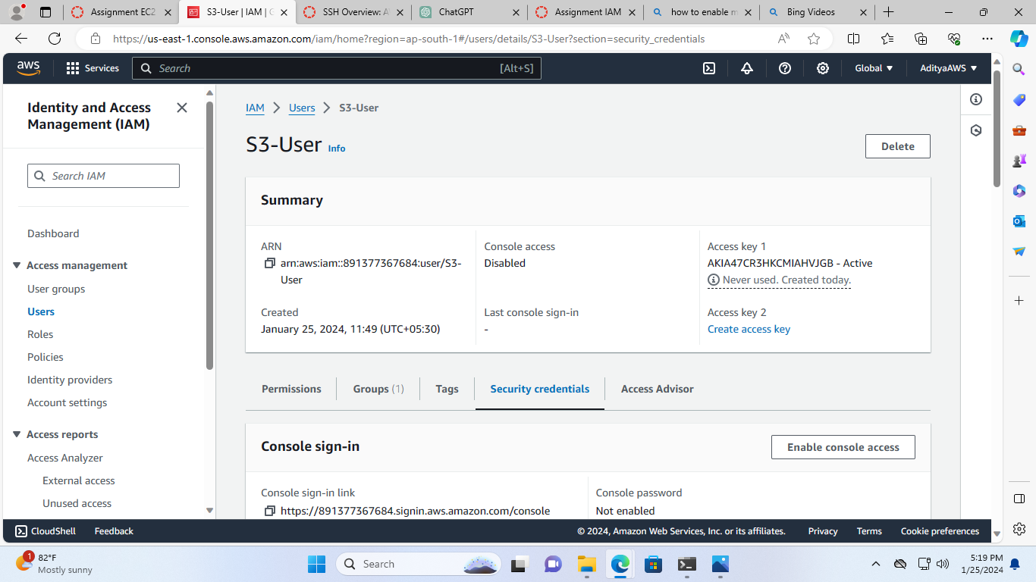

* In security credentials click on “Assign MFA”

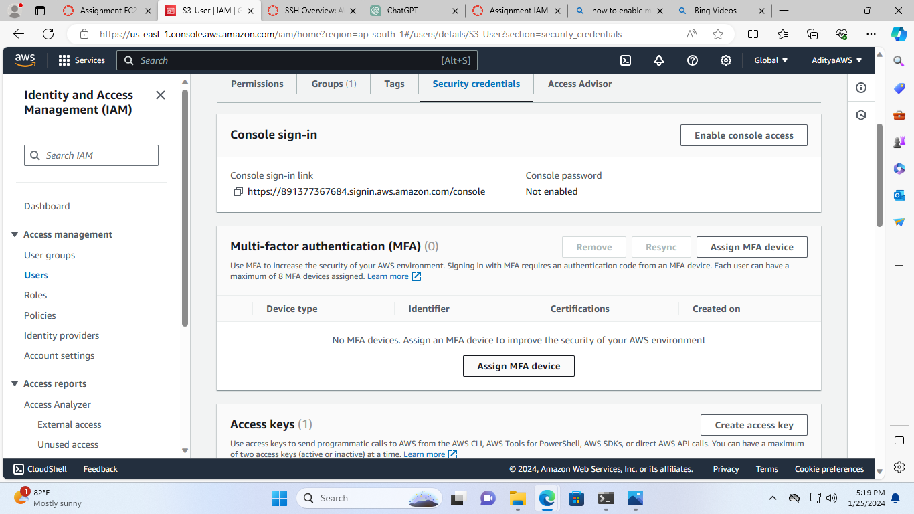

* After that, In the “Select MFA device” page name the MFA device.

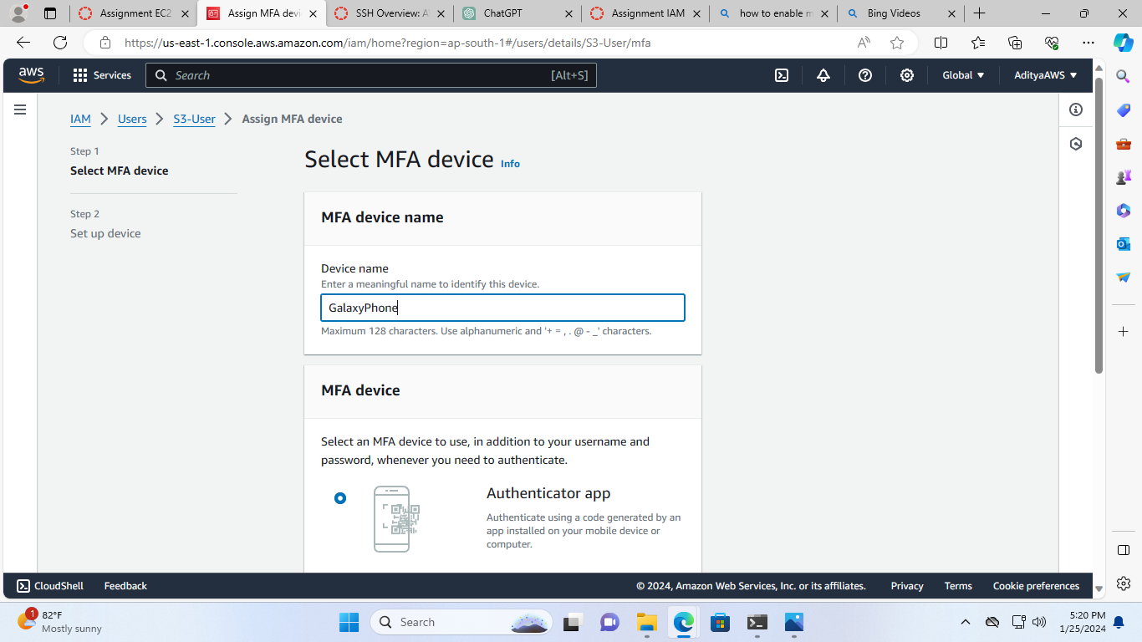

* Then, select an MFA device to use (I am selecting Authenticator app). And click “Next”.

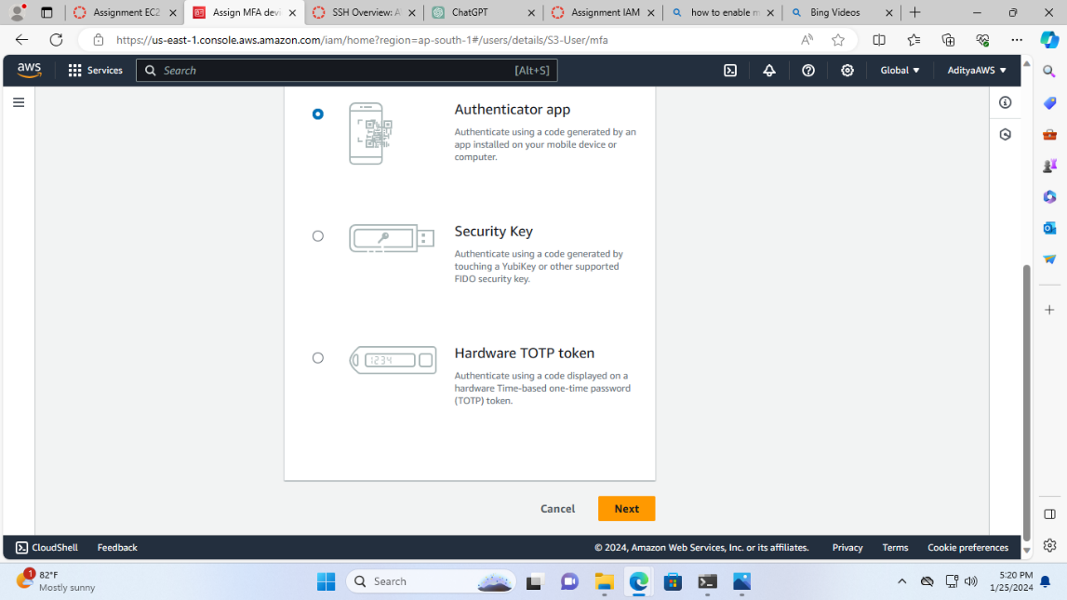

* Now setup the device, for this install a compatible application such as Google Authenticator on your mobile device or computer.

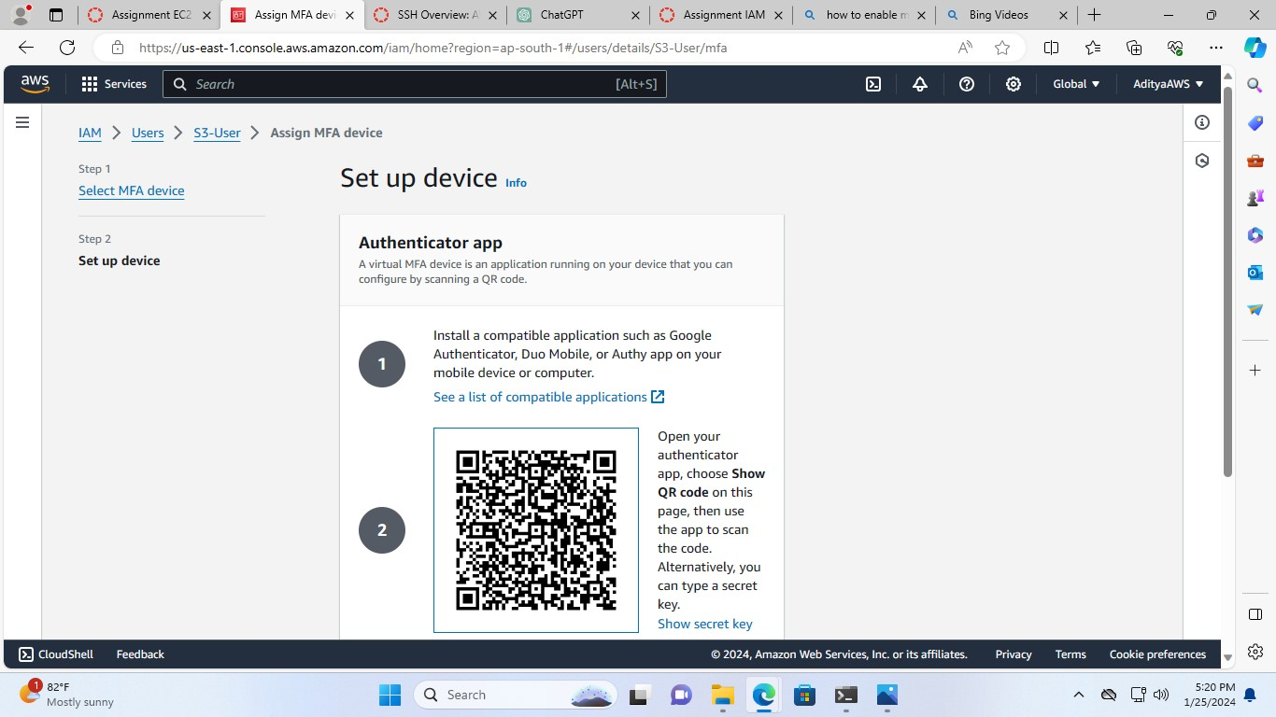And open the authenticator app, scan the QR code

* Fill in two consecutive authenticator codes from the MFA device.

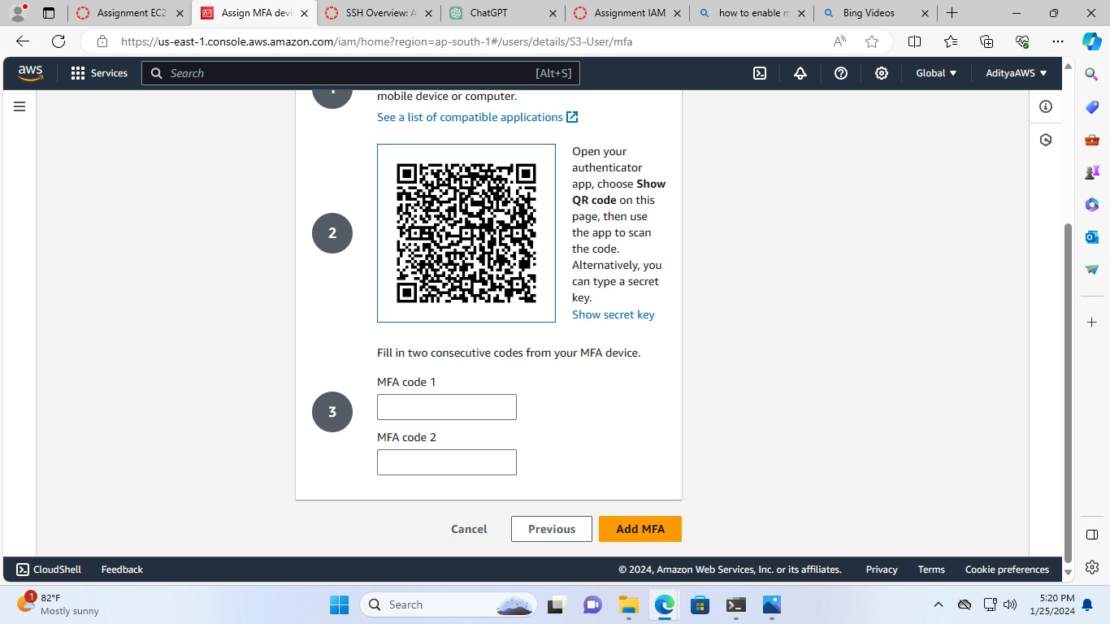

* Then, click on “Add MFA”.

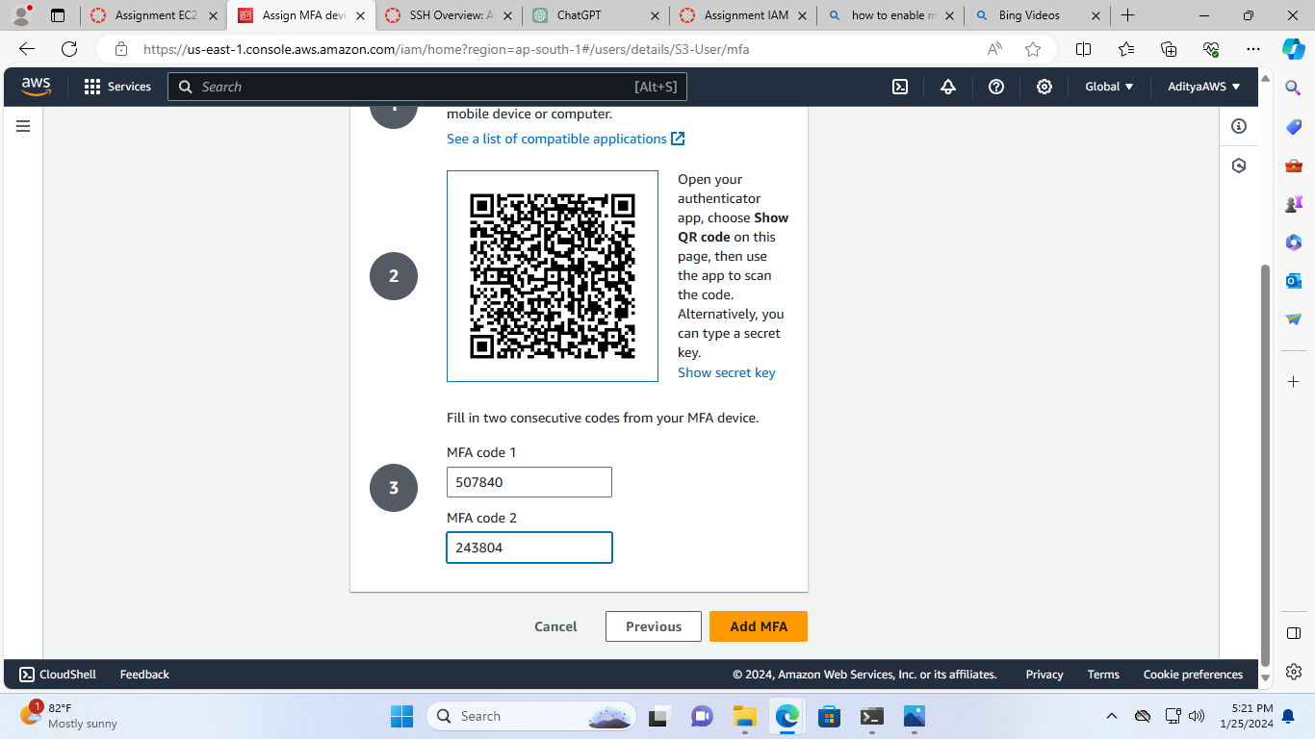

Thus, the MFA enabled successfully for “S3-User”

